**Plastic Injection Molding for PPE**

# Introduction

Personal protective equipment, commonly known as PPE, is equipment that protects the wearer from various hazards. It can be any equipment or clothing that ensures our safety in various industries. Some of the most familiar examples are Gloves, protective ear gear (earplugs, muffs), helmets, hard hats, goggles, respirators, and full-body suits. In this article, we will take a closer look at how plastic injection molding is revolutionizing the production of high-quality PPE. This article also presents an in-depth look at the material selection, design, quality assurance, and market demand and trends of PPE.

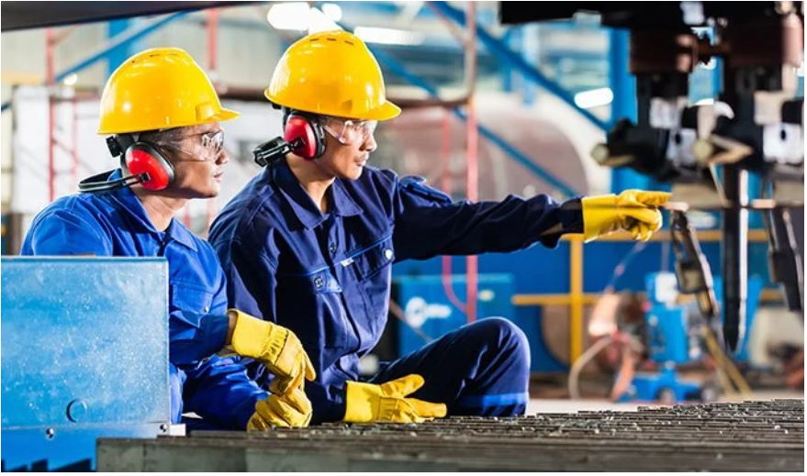

Figure 1 PPE(Personal protective equipment) (Source: https://blog.sliceproducts.com/blog/safety-equipment-manufacturers)

# The Importance of PPE

PPE plays a very crucial role in the safety of humans in different sectors, where life-threatening accidents can be avoided by just minor injuries. The uses of PPE are widely utilized in industries like, healthcare, manufacturing, mining, sports, movie stunts, and so on. For example, in manufacturing industries, PPE protects workers from hazards including chemicals, noise, heat, and flying debris. Overall, the severity of injuries that occur is very low compared to injuries without PPE. Workers are the [backbone of any operation](https://katanamrp.com/blog/operations-in-manufacturing/), and their safety should be a top priority. In the healthcare industry, PPE equipment like surgical masks and face shields is used to prevent infectious diseases. PPE boosts the confidence of the workers and makes them feel more comfortable while doing work, which leads to increased productivity in the industry. This makes a workplace safe and sound for everyone spreading a positive attitude and motivation to do the best work among workers. So, PPE is just not a set of gears, they are the shield of humans.

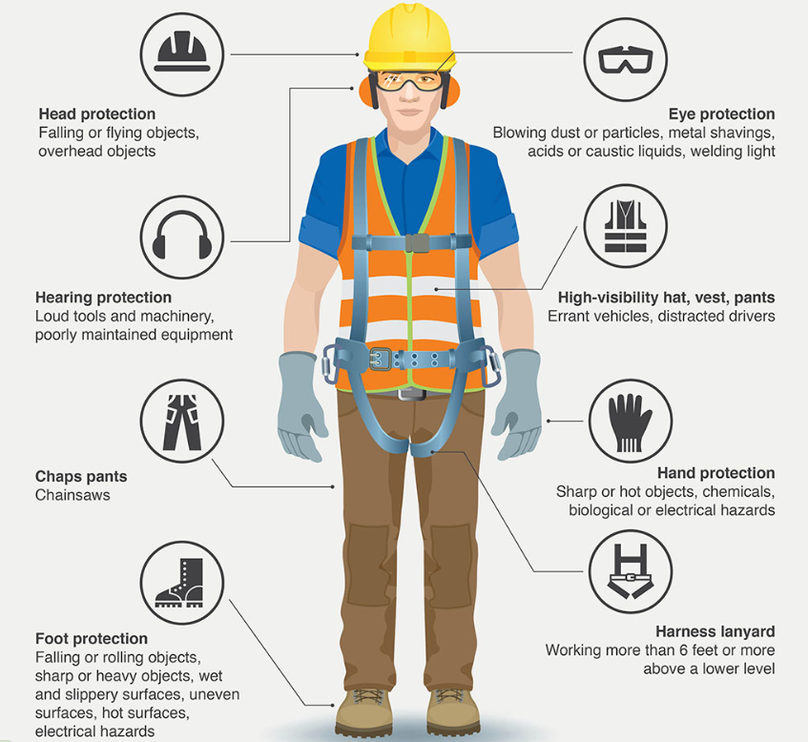

Figure 2 Types of PPE and its uses (https://www.mnltap.umn.edu/topics/workplace/personal_protection_equipment/)

# Material Selection for PPE

Material selection is the key factor for effective PPE. The material selection of PPE varies according to their purposes and sectors. For example: a helmet requires high-impact resistance and firefighter gloves require inflammability. In addition, the selection of the material for PPE heavily depends upon the material properties. Plastics are the most common material that is used in the production of PPE. Plastics are durable, lightweight, flexible, and chemical resistant. This makes them an ideal and cost-effective choice for the manufacturing of PPE. Furthermore, Plastics can also be molded into any desirable shapes and sizes to fit the specific needs of the user. However, all plastics are not suitable for the PPE. Some of the most popular and widely used plastics for PPE are listed below:

* **Polyethylene (PE):** It is a versatile plastic that is used for helmets, gloves, masks, and other protective clothing. It has properties like high impact strength and tensile strength. It is also a low density material with chemical and moisture resistance properties. Its common use is in the production of helmets, gloves, masks, and other PPE clothing.

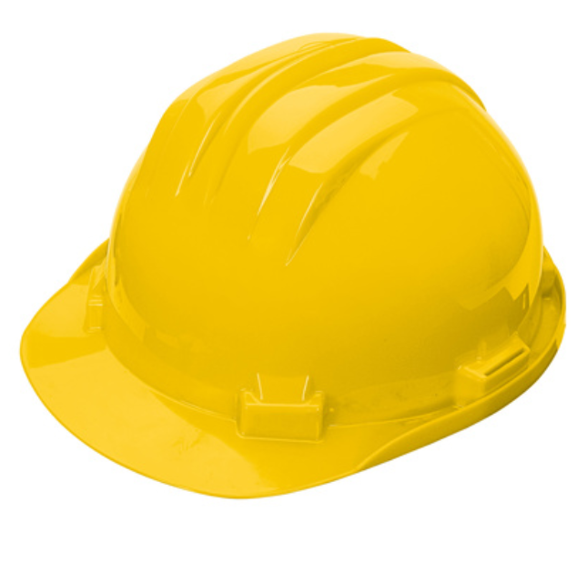

Figure 3 Protective helmet made up of Polyethylene (source:https://www.singer.fr/en/p/polyethylene-safety-helmet/CAS5RSY)

* **Polypropylene (PP):** Polypropylene has high tensile strength and provides good resistance to bacteria and fungi. The common applications of polypropylene are surgical masks and N95 respirator masks.

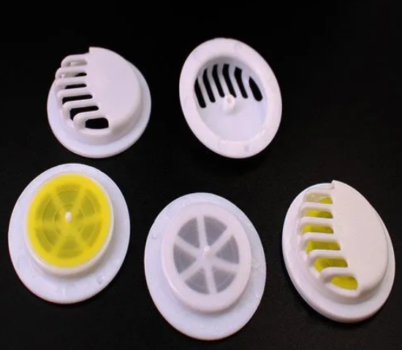

Figure 4 respirator mask valve made up of Polypropylene( source : https://www.indiamart.com/proddetail/round-plastic-respirator-mask-valve-particular-for-n95-face-dust-protector-filter-22308767491.html)

* **Polycarbonate (PC):** Polycarbonate is a plastic with high impact and thermal stability. It also offers transparency for its application. So , most of the uses are in production of goggles, visor, etc.

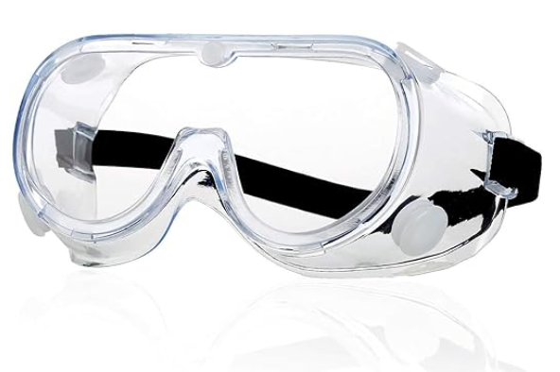 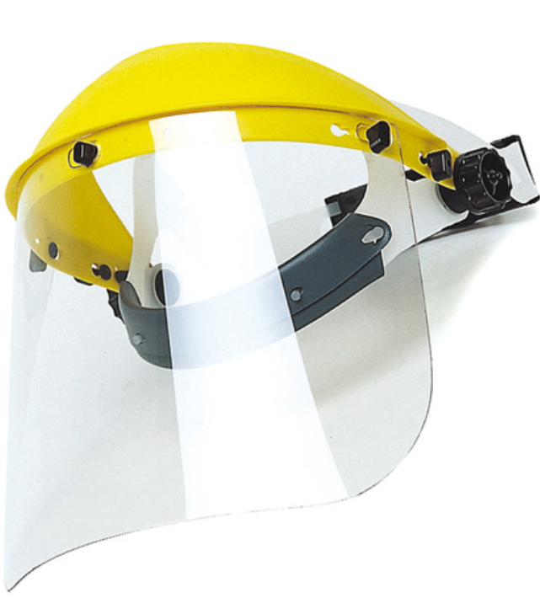

Figure 5 PPE goggle and visor shield made up of polycarbonate (source:https://www.singer.fr/en/p/protective-face-shield-clear-polycarbonate-visor-305-x-190-mm/EVA805)

* **Polyvinyl chloride (PVC):** Polyvinyl chloride has high flexibility, durability, and resistance to acids and alkalis, which makes them best option for the production of boots, aprons, etc. In addition, they also provide resistance to acids.

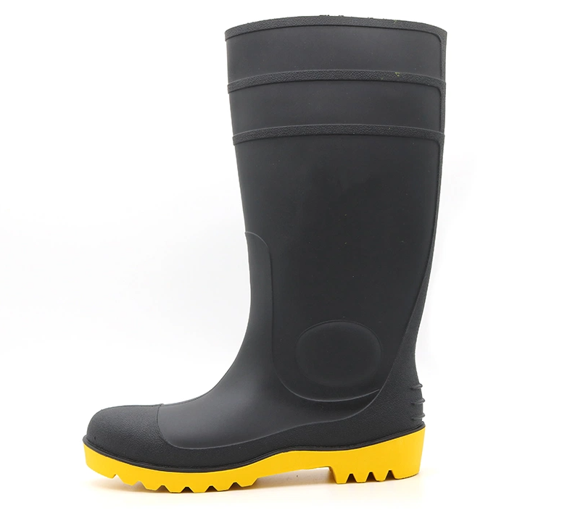

Figure 6 acid and alkali resistant safety boot made up of PVC (source :https://saferltd.en.made-in-china.com/product/fZaGTVPvYepo/China-CE-Verified-Anti-Slip-Waterproof-Oil-Acid-Alkali-Resistant-Steel-Toe-Puncture-Proof-Antistatic-Men-PPE-Protective-Construction

* **Polyamide (PA):** Polyamide, commonly referred to as nylon, are commonly used as safety vests and jackets. Also, they are used in the manufacturing of bulletproof jackets.
* **Acrylonitrile butadiene styrene (ABS):** This is a thermoplastic polymer with strong, rigid, and impact-resistant properties. They are heat-resistant and easy to mold and finish. ABS is mostly used for making hard hats, earmuffs, and respirator parts.

# Injection Molding Process for PPE

Generally, the first step of injection molding for PPE is the part design using CAD software. Then, The molds are designed with added inlet gate(s) and initial venting. and fabricated with high precision to meet quality standards. Then the materials are injected into a mold with high pressure, and this process is called injection molding.

Injection molding is one of the most used methods in production of PPE. The plastic injection molding process for PPE involves heating plastic in pellet or grain form until it has melted. Then, the molten plastic is then injected into a closed two-part mold under high pressure. The mold is cooled and molten plastic solidifies to the desired shape. The component is then removed from the mold and is sent for additional processing if necessary.

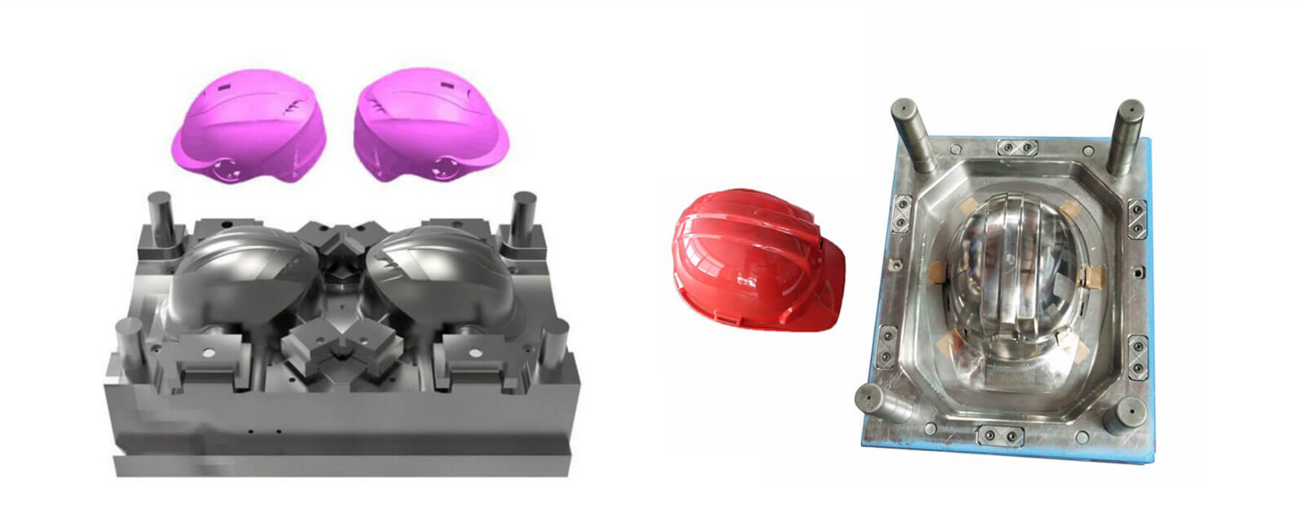

Figure 7 injection molding for safety helmet (source:https://immsolution.com/product/safety-helmet-injection-molding-machine/)

Injection molding offers many advantages for producing PPE over other manufacturing techniques such as:

* Precision: Injection molding offers the production of complex shape products and intricate details with high accuracy and consistency. Thus, it remains as a superior choice of manufacturing method in the context of precision.
* Efficiency: PPE is produced on a large scale with each product being identical to the other. This efficiency capability makes it superior choice of manufacturing compared to other technique in mass production.
* Wide range of materials: There are different types of PPE made of various plastics. Injection molding can work with these various types of plastics to create products with different properties and features.
* Customization possibilities: Injection molding can allow for branding and adding personal or safety information in PPE products. This allows the company to involve its product details and identification like badge, logos, cautions, etc.

Injection molding can create high-quality PPE that than any other technology for various industries and applications. Therefore, injection molding is the best technique for manufacturing PPE within short period of time.

# Design and Customization of PPE

The world of personal protective equipment has evolved significantly. Design is the crucial step for the development of personal protective equipment. Design should not be just based on only about aesthetics but also on functionality and user comfort. PPE should be designed in such a way that it optimizes its performance and usability while minimizing its drawbacks and risks.

Let's explore some of the crucial aspects of design considerations and customization possibilities in PPE manufacturing.

* **Ergonomics and comfort:** PPE is just not for protection, but the worker should feel comfortable while wearing it. That’s why PPE should be designed ergonomically to fit and the wearer should be able to move freely.
* **Functionality:** PPE should serve its intended purpose effectively. For instance, a face shield designed for full facial coverage should also allow for easy breathing and communication.
* **Biocompatibility:** Ensuring the safety of patients and users is most important when it comes to PPE. That's why PPE that’s in contact with the human body must be designed considering biological safety. Therefore, appropriate material should be selected according to the intended use.
* **Maintenance and reusability:** PPE should be designed in such a way that it can be maintained with a low budget and can be repeatedly used without compromising its efficiency.
* **Quality standards:** Designer must focus on standards set for PPE while designing according to the risk associated. There are various governing bodies for PPE standards according to different regions:  Occupational Safety and Health Administration (OSHA), Conformité Européene (CE), EN ISO, etc.
* **Durability:** PPE is often subjected to harsh conditions. PPE should be able to withstand wear and tear ensuring a longer lifespan and cost-effectiveness.
* **Adaptation to hazards:** Different industries face varying hazards. Customized PPE can be designed to offer specialized protection. For example, PPE for construction workers may need to withstand impact, while healthcare workers require protection against biological hazards.
* **Branding and identifications:** Customization extends beyond fit and comfort. PPE needs to be branded with company logos or identification marks, such that it simplifies tracking and management within organizations.
* **Sizing:** Traditionally, PPE used to be designed and sized for the average male body. As the workforce has become more diverse, protective equipment must be designed for various sizes of people according to different age groups, races, sexes, etc.
* **Fit and filtration:**  Poorly designed and ill-fitting PPE reduces the safety provided to the wearer. For example, an N95 respirator mask should cover both mouth and nose properly and should fit the wearer. Also, it should filter the contaminated particles and protect the wearer.

The design and customization of PPE are pivotal in ensuring both safety and user comfort. With injection molding technology, we can achieve tailored solutions that address the unique needs of diverse industries and users. Designing and customizing PPE can improve its effectiveness and user satisfaction. However, designing and customizing PPE also requires adhering to quality standards and regulations.

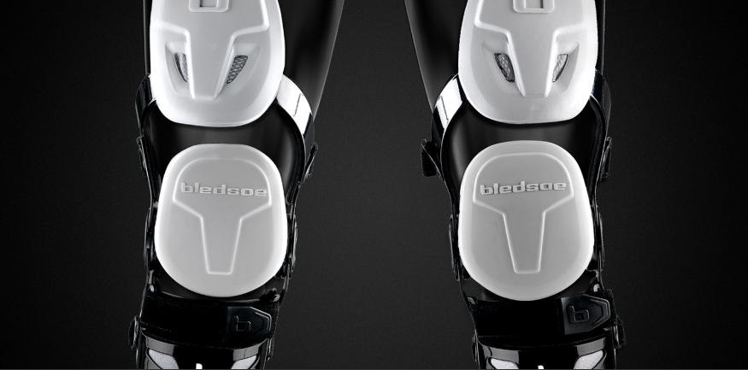

Figure 8 PPE gear set for sports (source :https://www.prioritydesigns.com/personal-protective-equipment-ppe-product-development/)

# Quality Assurance and Standards Compliance

In the previous section, we discussed that design must be based on the quality standards and regulations maintained by governing bodies like OSHA, CE, ISO, etc. There are many other methods that the manufacturers had to follow in the production of PPE. Here is an overview of the key quality control measures and standards applicable to PPE:

* **Regulatory Agencies:** There are many regulatory agencies that sets guidelines and standards for PPE. These agencies and standards differ from region to region. For example :OSHA (for USA), CE( Europe), HSE (UK) etc.
* **Material Standards:** Materials must be selected according to their mechanical properties like tensile strength, impact resistance, flexural strength, durability, chemical resistance, etc. For example, the Helmet should be made up of FRP (fiber-reinforced plastic) which should meet the standard IS 2925 or EN 397. Safety Goggles should be made up of polycarbonate material & meet the Standard ANSI Z87.1 2003 or EN166. Etc.
* **Product Testing and validation:** PPE products must undergo various testing to ensure they meet safety and performance standards. Depending on the type of PPE and its applications, tests may include impact resistance, penetration resistance, flame resistance, chemical resistance, and more. These tests ensure that the PPE are reliable enough to be used in hazardous environments.
* **Certification:** PPE manufacturers often seek third-party certification for their products to verify compliance with relevant standards. Some certification bodies are UL (Underwriters Laboratories), NIOSH (National Institute for Occupational Safety and Health), and TÜV (Technischer Überwachungsverein) in Germany.
* **Product Labeling:** PPE must be properly labeled with all the information that’s needed for the wearer etc. Most PPE manufacturers use color codes for their products according to the risk associated and their applications.

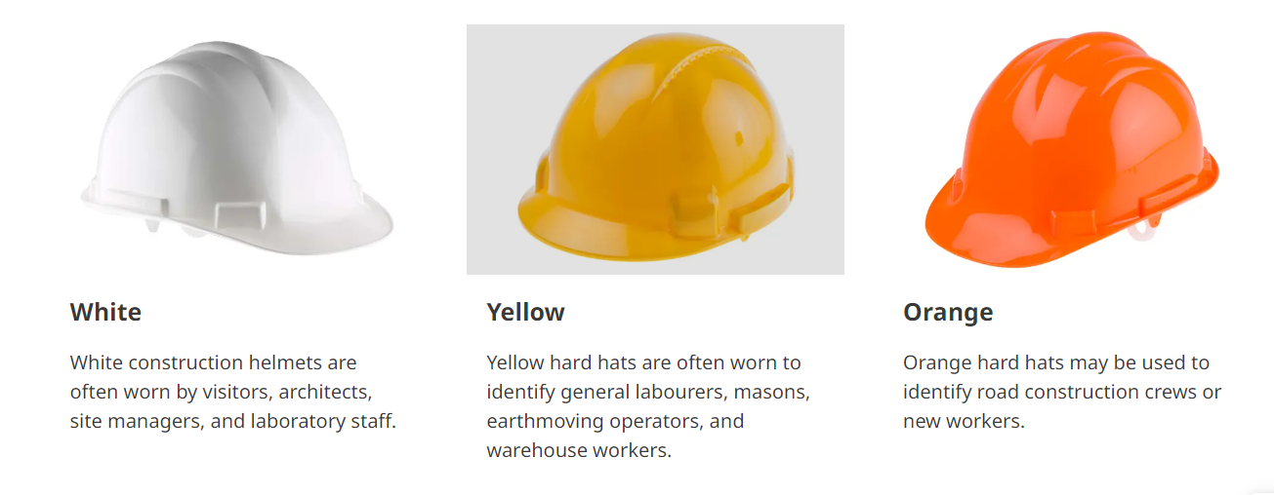

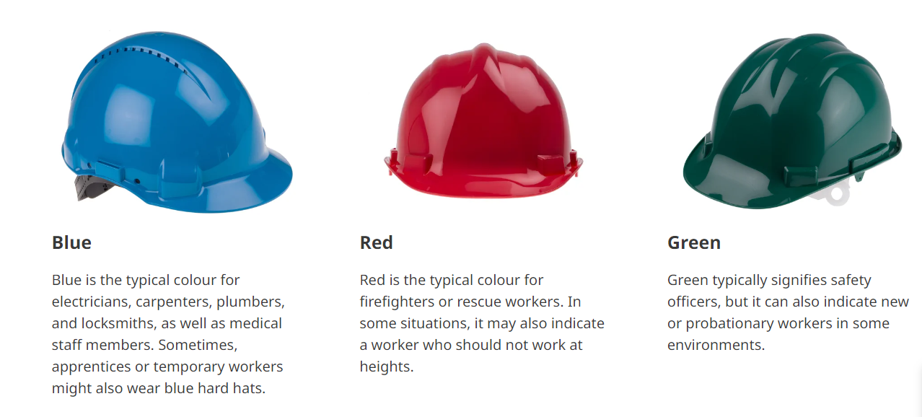

Figure 9 Color labeling of helmets for various application

Quality assurance and standards compliance ensure that the PPE products are reliable and trustworthy for users. It enhances the reputation of the PPE manufacturers and suppliers. It is important to choose the one that follows the quality control measures mentioned above and adheres to all standards set for the equipment when selecting a PPE manufacturer for your business,.

# Market Demand and Trends in PPE Manufacturing

The demand for high-quality Personal Protective Equipment (PPE) has hiked since COVID-19 pandemic and growing awareness of workplace safety. The market shows that there has always been demand for PPE across various industries including healthcare, construction, manufacturing, and more. This heightened demand doesn’t only reflect the COVID-19 pandemic situation but also the awareness of the organization of their worker safety. The need for PPE has always been there and will continue to exist. The COVID-19 pandemic just exposed the importance of PPE among users PPE industry will continue to grow with advancements in technologies.

The market for PPE has significantly increased since the COVID-19 impact. North America is the highest consumer. The global market for personal protective equipment (PPE) was valued at $80.38 billion in 2022 and is projected to grow at a CAGR of 4.7% during the forecast period. It is forecasted to reach $121.51 billion by 2031.

Read More at:-

<https://www.fortunebusinessinsights.com/personal-protective-equipment-ppe-market-102015>

**Trends and Innovations:**

 Here are some of the trends and innovations that are shaping the future of PPE manufacturing:

* Technological Advancements: PPE manufacturers are using innovative materials and smart technologies to add comfort and enhance the protection of PPE.
* Sustainability: Eco-friendly PPE options are gaining attraction. This promotes the global sustainability goal while offering biodegradable or reusable PPE solutions.
* Customization: PPE that fits for various sizes of humans is on the rise due to diverse sizes and workforces from industry to industry.

**Challenges and Opportunities:**

* Supply Chain system: The major challenge for every PPE manufacturer is difficulties in sourcing and delivering PPE. Another issue includes uncertainty of raw materials availability . We are all aware of shortage of PPE during the COVID-19 pandemic due to disrupted supply chain. The supply chain system that is reliable in every situation is essential to be built.
* Meeting standards: One of the major challenges is meeting the evolving safety and quality standards. The companies that can match these standards while maintain same level of quality PPE will have greater impact in the market.
* Proper training and education on correct usage: There can be challenges in providing proper training and education on the correct usage of PPE. The companies should focus on making tutorials or training programs to extend their product’s awareness.

The PPE manufacturing industry has transformed drastically because of awareness and demand for safety. Innovation in technologies and materials has remarkable effect in growth of PPE usage in various industries. The companies that adapt to these changes while addressing the challenges and opportunities will have a major role in safeguarding the workplace worldwide.

# Conclusion

Plastic injection molding is the go-to method for creating high-quality PPE. However, there are some careful considerations like material selection, design consideration, quality control and standards to be made for the manufacturing of effective and efficient PPE. The PPE market will keep growing with the growing demand and awareness of the workplace. Therefore, the demand for high-quality PPE will continue to exist with advancements in technologies, customization, and reliable supply chain systems. Lastly, PPE is not just a product. It is a lifeline for people who work in hazardous and risky environments. Therefore, it is our moral responsibility to equip them with high-quality and precise injection-molded PPE.